Annual Business Survey 2019

By: Luke Natalo, Ryan Shell,

Brian Moritz, and Aaron Janaszak

Data Sources:

Bureau, U. S. C. (2021, March 21). *Annual Business Survey (ABS) APIs*. The United States Census Bureau. Retrieved October 7, 2021, from <https://www.census.gov/data/developers/data-sets/abs.2019.html>.

Initial Questions:

* How does the sex of the company owners in Vermont compare to the sex of company owners in Wyoming?
* How does the veteran status of the company owners in Vermont compare to the veteran status of company owners in Wyoming?
* How does the race of the employers in Vermont compare to the race of employers in Wyoming?
* How does the number of employees relate to the listed annual payroll for companies in the two states?
* What is the most common number of sales for a company to have?

Answering Our Questions:

To answer our questions, we first imported and cleaned the data we needed from the Company Summary Data available from the Annual Business Survey (ABS) API. Once our data was filtered down to the states of Vermont and Wyoming, we began to create graphs that compared each column of data that we were interested in. First, let us highlight the locations of these two states in the map below.

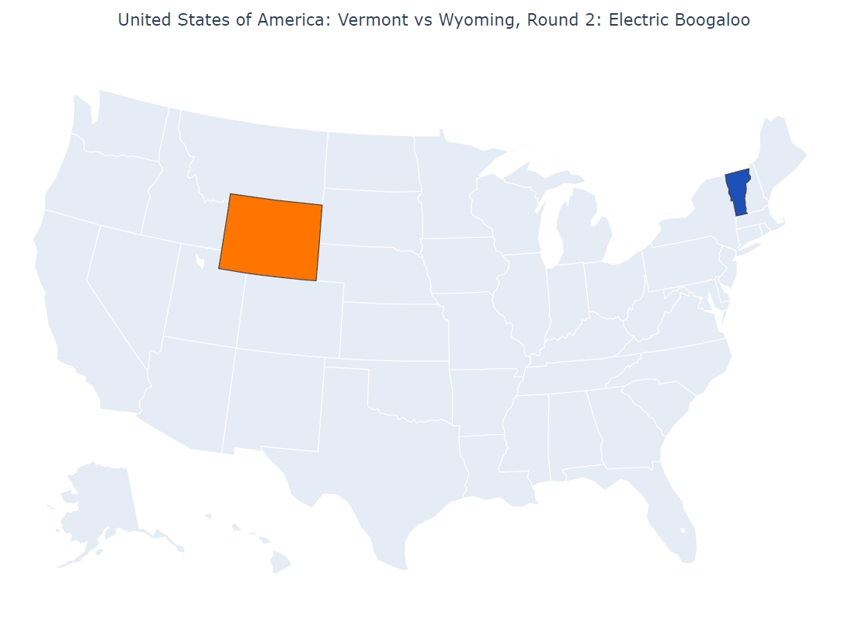

Second, we compared the sexes of each state and found that both Vermont and Wyoming share a trend when considering the amount of males and females that own businesses. It is worth mentioning that the values in our graphs may be skewed due to the nature of the survey and that quite a few of its questions were not required to be answered.

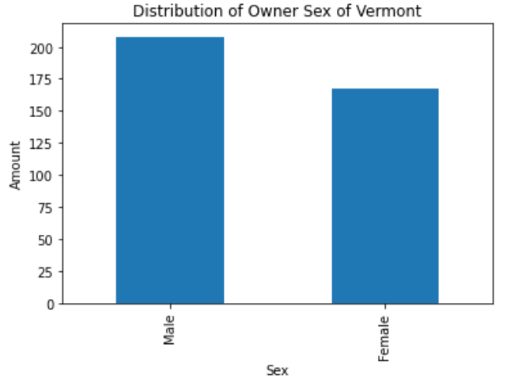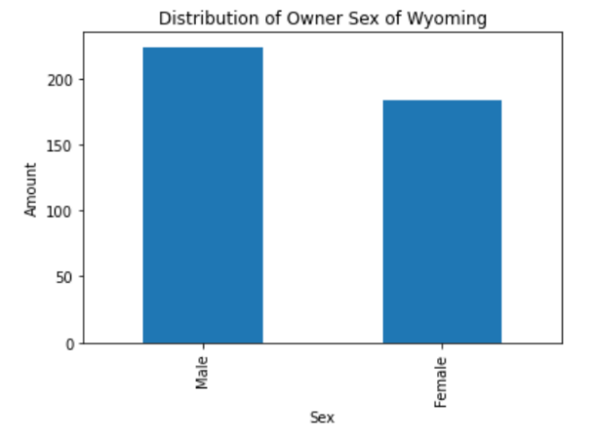

Separately, these graphs are useful to see an individual state’s breakdown of owner sex. If you wanted to compare the two states against one another, the graph below is catered to that effect:

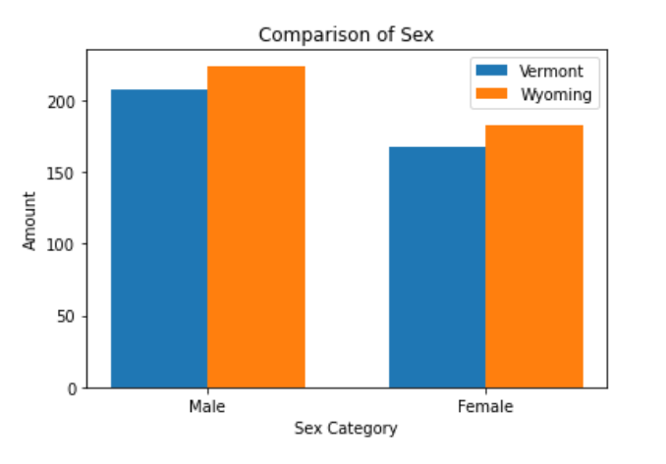

We were interested in exploring the veteran status of these company owners. Like the previous section, this data is split between the states before showing a merged version for comparison purposes.

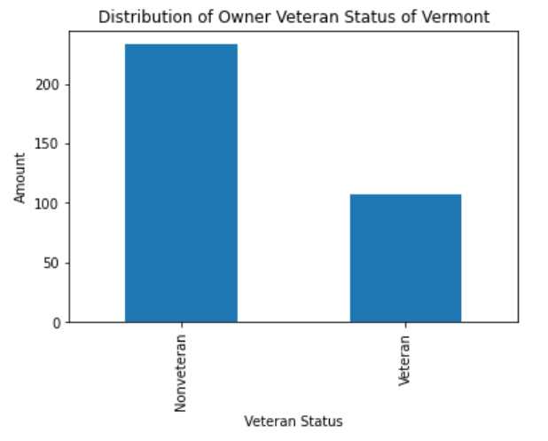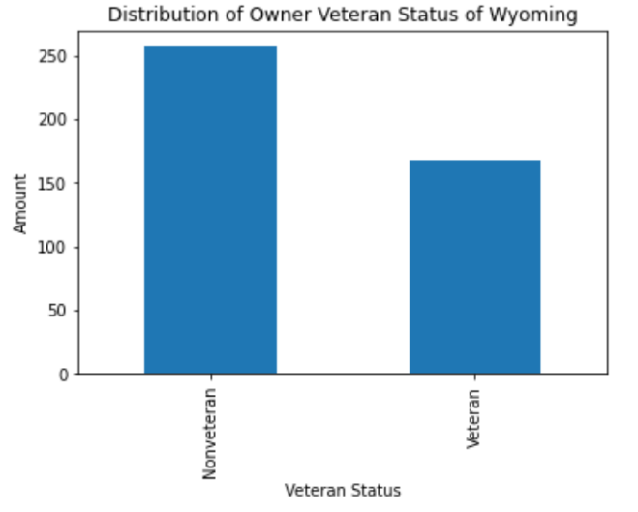

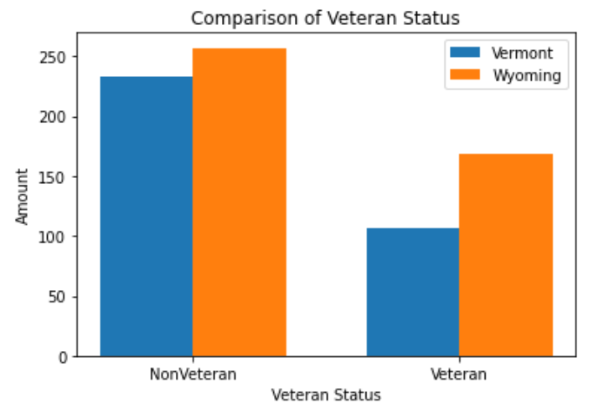

We can see that both Vermont and Wyoming have a similar number of nonveteran business owners. However, Wyoming has significantly more veteran business owners than Vermont. It may be interesting to investigate why this is the case. Do more people from Wyoming join the military, is Wyoming a common place for veterans to go after they have served, or is there another explanation?

So far, we have looked at Sex and Veteran Status of the business owners in Vermont and Wyoming. Next, we are going to explore the distribution of races within these states. Instead of having just a binary comparison of “this” or “other,” we now have multiple categories as can be seen below.

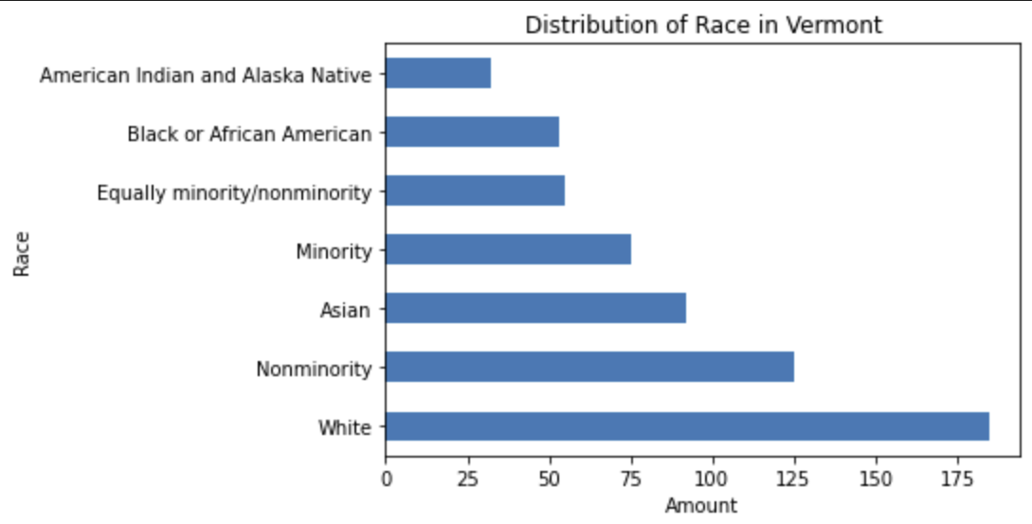

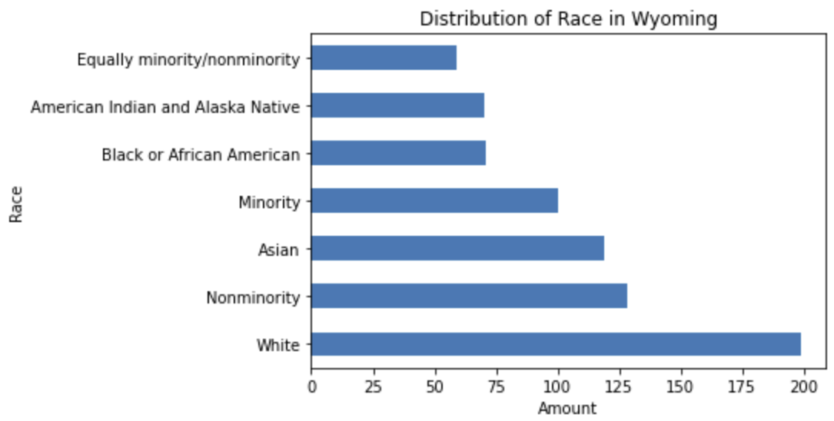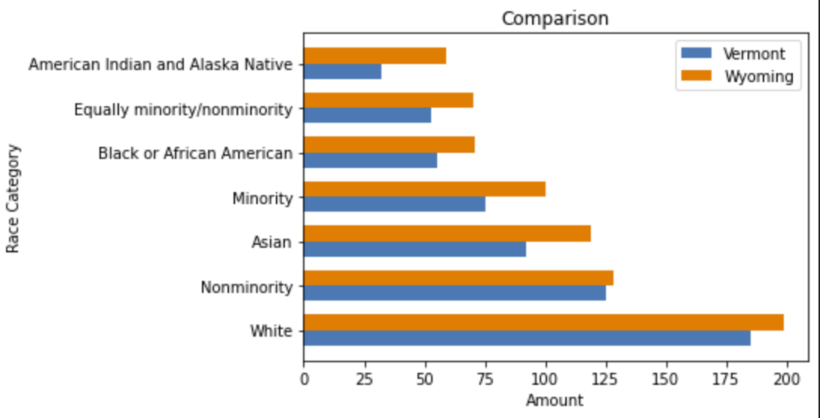

Both states’ companies are primarily owned by white people. There are a few ambiguous labels in the data such as “Minority” or “Nonminority” but since the survey results are not truly impacted by these extra categories, it would be disingenuous to omit them from the dataset. Next, we’ll look at some financial aspects of companies in these states.

This section of the report covers a category labeled as ‘receipts’, which encompasses the sales, receipts, and revenue size categories of the firms.

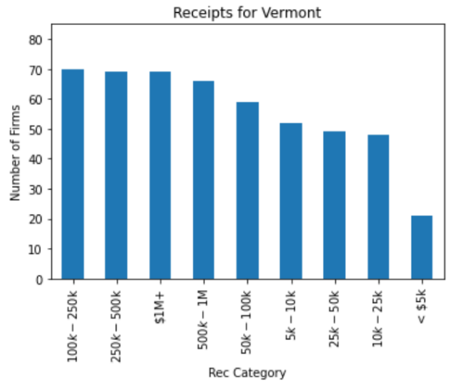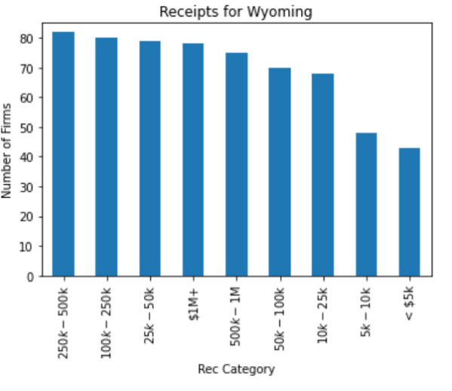

Because the y-axes for these graphs are all the same, you can tell that Wyoming seems to have a larger number of firms in almost every category. The graph below reveals that to be the case, except for the category with values between $5,000 and $10,000 where Wyoming and Vermont appear to have the same number of firms.

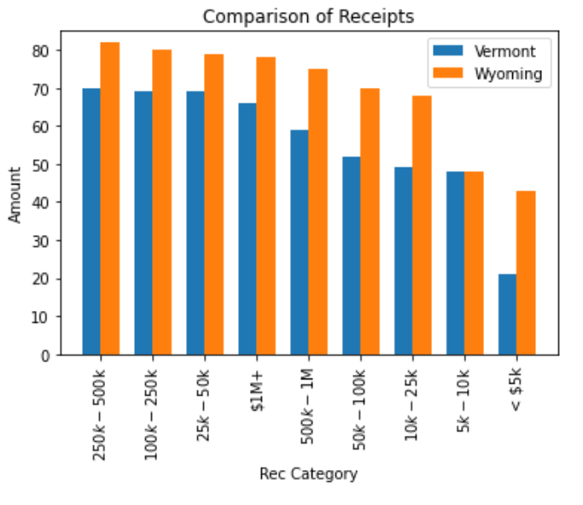

An interesting case appears at the low end of Vermont’s businesses. Very small businesses seem to break the trend and drop off rather quickly from the (relatively) small decreases. Similarly, Wyoming businesses drop off around the $10k mark but do not drop again after the $5k threshold. Again, we’re looking at the number of firms that responded to this survey, that were in Vermont and Wyoming. A notable decrease is considered as >10%.

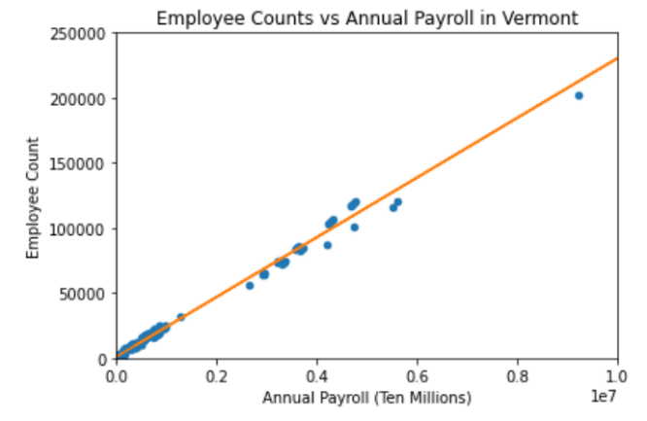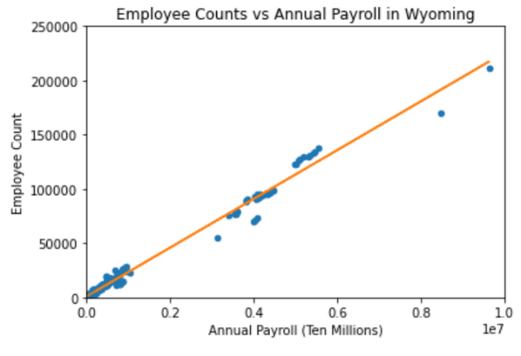

Finally, we wanted to look at the number of employees a company employs compared to the annual payroll a company has for both Vermont and Wyoming. As you can see for both Vermont and Wyoming, as the number of employees for a company goes up so does the annual payroll of that company. This is not a surprise at all, and it is good to see that the data supports what we think logically should happen.

One thing that is interesting to compare between Vermont and Wyoming is where each of the three “clusters” of dots start and end. For example, in both Vermont and Wyoming the businesses having less than 50,000 employees also only have an annual payroll ranging from the tens of thousands to about 1,000,000. In the middle cluster, where Vermont and Wyoming both have employee counts between 50,000 and 150,000, Vermont’s annual payroll ranges from about 2,000,000 to 6,000,000, whereas Wyoming’s ranges from about 3,000,000 to 6,000,000. This could indicate that medium sized business in Wyoming pay their employees more than medium sized businesses in Vermont. Finally, when looking at the few dots for Vermont and Wyoming having more than 150,000 employees, we can see that Vermont has only one company with an annual payroll of about 9,000,000 and Wyoming has two companies that range from about 8,000,000 and 10,000,000 in annual payroll. Unfortunately, I would say there is not enough data for this range of companies to draw any conclusions.

**Feedback Response:**

Feedback from our presentation requested that we adjust the scales of the last two graphs to match, helping to compare them easier. A simple code addendum setting our x- and y-axes limits quickly resolved that issue. In addition to the equivalent scales, a trendline was added, also a fix from our presentation critique. We then adjusted our colors to be consistent through all our visualizations.